**PIZZA SALES SQL QUERIES**

1. **KPI’s**
2. Total Revenue

select sum(total_price) as Total_Revenue from pizza_sales;

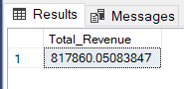

1. Average Order Value

SELECT SUM(total_price)/COUNT(DISTINCT order_id) as Average_order_value

from pizza_sales;

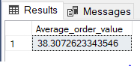

1. Total Pizzas Sold

SELECT SUM(quantity) as Total_Pizza_Sold from pizza_sales;

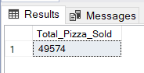

1. Total Orders

SELECT COUNT(DISTINCT order_id) as Total_order

from pizza_sales;

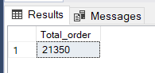

1. Average Pizzas Per Order

SELECT CAST(CAST(SUM(quantity) AS DECIMAL(10,2))/

CAST(COUNT(DISTINCT order_id) AS DECIMAL(10,2)) AS DECIMAL(10,2)) as Average_pizzas_per_order

from pizza_sales;

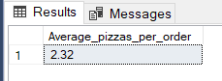

1. **Daily Trends for Total Orders**

SELECT DATENAME(DW, order_date) as Order_day,COUNT(DISTINCT order_id) as Total_orders

from Pizza_sales

group by DATENAME(DW, order_date)

Order by DATENAME(DW, order_date) DESC;

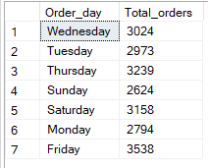

1. **Monthly Trends for Orders**

SELECT DATENAME(month,order_date) as Order_month, count(distinct order_id) as Total_orders

from pizza_sales

group by DATENAME(month,order_date);

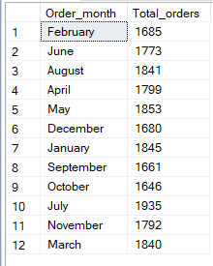

1. **Percentage of Sales by Pizza Category**

select pizza_category, sum(total_price) as Total_sales,

(sum(total_price)*100)/(select sum(total_price) from pizza_sales where MONTH(order_date)=1) as PCT

from pizza_sales where MONTH(order_date)=1

group by pizza_category

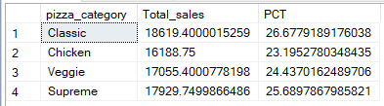

1. **Percentage of Sales by Pizza Size**

select pizza_size, sum(total_price) as Total_sales,

(sum(total_price)*100)/(select sum(total_price) from pizza_sales) as PCT

from pizza_sales

group by pizza_size;

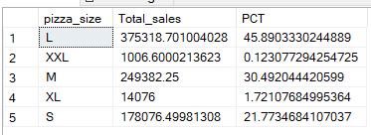

1. **Top 5 by Pizzas by Revenue**

select Top 5 pizza_name, sum(total_price) as Revenue

from pizza_sales

group by pizza_name

order by Revenue desc;

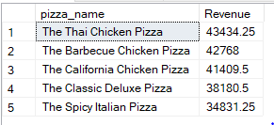

1. **Top 5 by Pizzas by Quantity**

select Top 5 pizza_name, sum(quantity) as Total_Quantity

from pizza_sales

group by pizza_name

order by Total_Quantity desc;

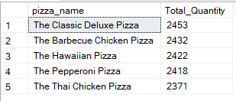

1. **Top 5 by Pizzas by Total Orders**

select Top 5 pizza_name, count(distinct order_id) as Total_orders

from pizza_sales

group by pizza_name

order by Total_orders;

